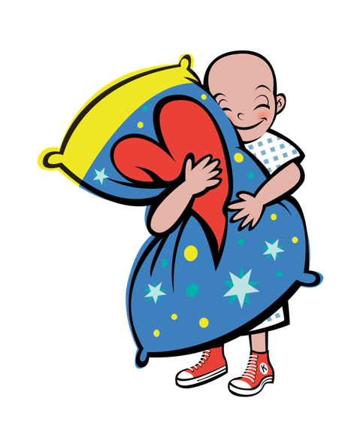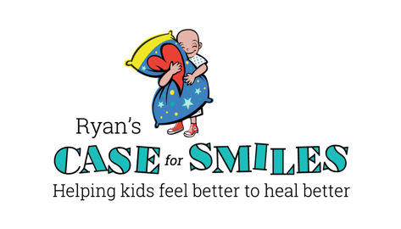

**GET STARTED**

◆ Set a Date

❖ Spread the Word

⬥ Collect Donations

 Wear Your Pajamas

It’s that easy!

Please make checks payable to Ryan’s Case for Smiles, Attn: Liz, 295 E. Swedesford Rd., #396, Wayne, PA 19087

**Contact:**

Cindy Berlacher

Cberlacher@caseforsmiles.org

Wear Your Pajamas to Practice

to **Help Kids Feel Better to Heal Better**



www.caseforsmiles.org

**PJ DAY**